1. To configure Git and Bitbucket I first logged into my Bitbucket account. Next, since I already had an SSH key, I created a new directory on my computer to for this class called cs112s2015. Within this directory I then used the command “git clone git@bitbucket.org:gkapfham/cs112s2015-share.git” to clone the folder Professor Kapfhammer had previously shared with me. I was then able to pull the files from within that repository to my computer. Next I needed to create the folder to hold files I would need to share with the Professor. In this folder within the terminal I typed the command “git init” to activate it as a git repository. Next it was necessary to perform three more commands in the terminal window:
“1349 git remote add origin git@bitbucket.org:guillaumes2/cs112-guillaumes.git”
“1350 git push -u origin --all # pushes up the repo and its refs for the first time”
“1351 git push -u origin --tags # pushes up any tags”
I then shared this repository with Professor Kapfhammer so he can review my coursework.

2.
git init: creates a git repository for the folder in which this command is executed
git status: this command reports the status of the repository, if it needs to be updated or not
git add: the change to a file has been staged, which means git knows the file has been changed, but the repository has not made the changes final yet
git commit: the file is saved to the repository and the working directory is clean
git push: the repository receives changes pushed to a shared repository
git pull: replicates changes made in a remote repository to the current one (can alter files in one repository from different machines)

4.
a. To compile and run the tow programs I first opened a terminal window from the folder both the files were located in: “cs112S2015-guillaumes2”. In the terminal I ran the command to compile Hooray.java and Weeee.java by typing :javac *.java” which simultaneously compiled both programs. To run the program I then typed “java Hooray” and “java Weeee” for the result.

b.
Hooray.java
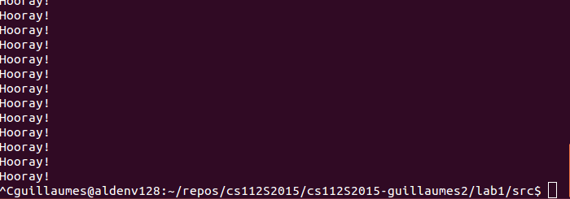

Weeee.java
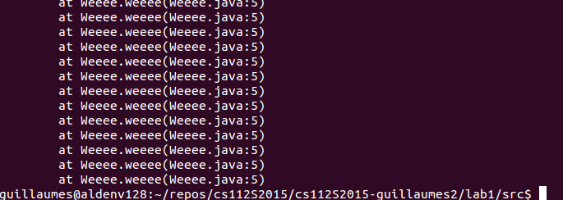

c. The output of Hooray.java was an infinite loop which printed the line “Hooray!” repeatedly until killed using the “ctrl + c” command. The output of Weee.java was a recursive loop. The program printed out “Weee!” for a brief moment until the terminal returns “at Weeee.weeee(Weeee.java:5) ” and the program stops running. Looking within the program for Weeee.java, the issue is discoverable, as indicated in the error message in the terminal, at line 5. The issue here is that the Weeee method is recursive, meaning it calls itself. Recursive methods resuld in infinite recursion which cause a stack overflow. In the Java Virtual Machine the Stack has a fixed amount of memory and when a method repeatedly calls itself, the Stack's memory is filled and the program crashes. This explains why we could briefly see the terminal print the message “Weeee!” while the stack was not yet full, and then the error message when the Stack's memory was filled and the program crashed.

d. These programs are similar in that they both use a main method that calls a method created before the main method call. The difference exists in the methods called by the main method. In the method weeee() tehre is no conditions and it is made infinite by calling itself, thus never having an effective way to exit and return to the main method. The hooray() method uses a while loop with the boolean condition true, the method does not have a command to change the condition and thus eventually exit the loop, so the system will print “Hooray!” infinitely.

